SIMATS ENGINEERING (SAVEETHA SCHOOL OF ENGINEERING) Department of Computer Science and Engineering
ASSESSMENT TOOL 3 – Comparative Analysis
Course Code: | CSA06 | Course Title: | Design and Analysis of Algorithms
CO Assessed: | CO4: Articulation (BL4, BL5) | Assessment: | Assessment Tool 3 – Comparative Analysis
Weightage: | 10% of CIA | Total Marks: | 100
CO4 Statement: | Solve optimization problems using dynamic programming and greedy strategies.
Student Name: | R.NANDHINI | Reg. No.: | 192524355
Section / Batch: |  | Date:

Instructions to Students
• Answer the following question. Total Marks: 100.
• Analyze the given questions thoroughly before answering.
• Compare multiple aspects such as methods, results, advantages, and limitations clearly. • Critically evaluate the strengths, weaknesses, and implications with proper justification. • Present meaningful insights, interpretations, and well-supported conclusions from the comparisons.

Question Type | Focus Area | Questions
Comparative Analysis | Comparative analysis of Dynamic Programming and Greedy algorithms for optimization problems. | Q1

CODE:
dice = int(input(" "))
target = int(input(" "))

dp = [0] * (target + 1)
dp[0] = 1

for d in range(dice):
new = [0] * (target + 1)
for s in range(target + 1):
for face in range(1, 7):
if s + face <= target:
new[s + face] += dp[s]
dp = new

print("number of ways =", dp[target])

OUTPUT:
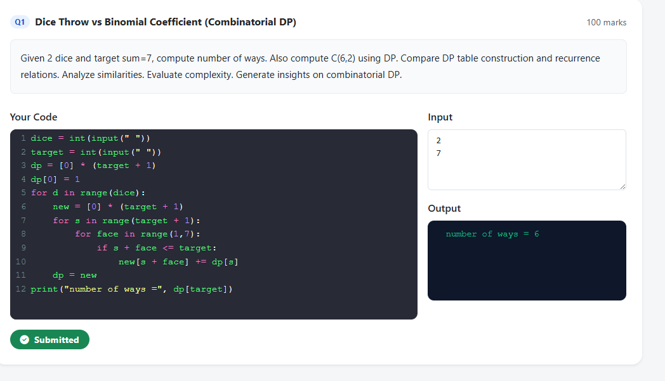

SECTION A – Comparative Analysis
Code of Conduct
I __________________________ (Name / Reg No) certify that this submission is my original work and that I have adhered to the guidelines specified for this assessment. I understand that any violation of academic integrity rules will result in disciplinary action.
Signature of the Student: _________________________

RUBRICS FOR CALCULATION
Comparative Analysis
Criteria | Weightage | Level 4 (Exemplary) | Level 3  (Proficient) | Level 2  (Developing) | Level 1  (Beginning)
Selection of  Studies/Parameters | 20% | Selects highly relevant and diverse studies with well-defined  comparison parameters | Selects relevant studies with minor gaps in parameter definition | Limited or  partially  relevant  selection | Poor or  inappropriate  selection of  studies
Comparison &  Differentiation | 25% | Clearly compares  multiple aspects  (methods, results,  limitations) with strong differentiation | Good comparison with minor gaps | Basic  comparison  with limited  depth | No clear  comparison;  mostly  descriptive
Critical Evaluation | 25% | Critically evaluates  strengths, weaknesses, and implications with strong justification | Provides  evaluation with  some justification | Limited  evaluation;  lacks depth | No critical  evaluation  provided
Synthesis & Insight Generation | 20% | Generates meaningful insights and conclusions from comparisons | Some insights  derived from  comparison | Limited or  unclear insights | No insights  generated
Clarity | 10% | Information is clearly presented  (tables/figures) with logical structure | Generally clear  with minor issues | Presentation  lacks clarity or structure | Poor  presentation and difficult to  understand

Marks Evaluation:
Criteria | Wt. | Level 4 –  Exemplary | Level 3 –  Proficient | Level 2 –  Developing | Level 1 –  Beginning
Selection of Studies/Parameters | 20%
Comparison & Differentiation | 25%
Critical Evaluation | 25%
Synthesis & Insight Generation | 20%
Clarity | 10%
Total Marks (100):

Faculty In-charge | Course Coordinator | Head of Department
Name: | Name: | Name:
Signature: _______________ | Signature: _______________ | Signature: _______________
Date: ___________________ | Date: ___________________ | Date: ___________________

